Walk 3 Sutton Walls & Marden
Last walked in March 2019

Description. An 8 km (5 mile) walk, fairly easy with no big hills as you walk across farmland and fields.
Start. From a lay-by opposite, and a little way up from Sutton-St-Nicholas church. Explorer Map 202 Grid 535455
Directions from Whitecross roundabout (Turn milometer to zero). Take the A4110 Canon Pyon (Three Elms road) for 1 mile and TR at the traffic lights onto the A4103 Worcester (Roman road). Continue on the A4103 towards Worcester and at the second roundabout, at 3.2 miles, TL, signposted Bodenham and Sutton-St-Nicholas. At 5.6 miles, TR at the cross roads, (just past a red telephone box and ‘The Golden Cross Bar and Restaurant’). Travel along the road a short distance and park on the L hand side just past the church, which is on your R (total 5.7 miles).

1. Sutton St Nicholas Church. The church is on your L as you walk back down to the cross roads by ‘The Golden Cross Bar and Restaurant’. Go straight across the crossroads and walk along the road ahead. After about ½ km, (just past a black and white house on the L called Ordis Cottage) you TR and walk up a wide enclosed bridleway, signposted ‘To Ordis Court’. Continue up the enclosed bridleway. A few hundred metres further on the track bends to the R, you carry straight on and go thru a gap in the hedge into F1. Keep to the L hand edge of the field as you climb up to reach a copse, where you TL into the copse. After about 20 meters in, you meet a track that goes around the bottom of the ramparts.

2. Sutton Walls Hill Fort. TR, after a short distance, by a way marker post, the track goes around to the L and follows the foot of the northern ramparts. Keep along the inside edge of the wooded area below the ramparts which are on your L and an orchard field is on your R. Travel around for about ½ km to reach a way marker post (R). If you want to go to the top of the ramparts continue on for a short distance and take the first track on the L, else TR by the way marker and go down the track to cross a stile into F2. Sutton Walls hill-fort was occupied from about 400 BC until the Roman Conquest. At Sutton Walls the average height of the adult males was 5 ft 8½ inches - this was actually taller than the average height of adult British males in the 1950s, when the site was excavated. Archaeological digs have revealed that around AD 48, 24 people were killed in the fort (probably by Romans) and thrown into the ditch. The skeletons show the wounds received, and some were decapitated. This did not end occupation, however, and the fort remained in use until around the 3rd century.

3. Sutton Walls Hill Fort. Continue down the R hand edge of F2, cross over another stile into F3. Continue on down the R field edge and at the bottom corner, (by a metal gate and stile), you TL and walk along the R field edge. Go thru two metal gates into F4 and walk along the L field edge, along a farm track, to go thru a gate onto a road. TR, walk along a short distance to a road junction on the L, Church Lane, and cross over to the war memorial. Continue down Church Lane to have a look around Marden Church, St Mary. St Mary’s church in Marden is made up of Kent ragstone, sandstone and a little crowstone, the oldest part of the building, the Chancel, dates from around 1200. The Tower dates back to the thirteenth century, and the reason for its unusual shape is that when the first six bells were hung, the original battlements and steeple were removed. The belfry was then enclosed with the white weatherboarding seen today which is known as a ‘snuffer’. The oldest of these six bells was dated 1693. There are two war memorials in the church, which can be found at the western end of the south aisle. They remember those villagers who lost their lives in the two World Wars.

4. War Memorial. Return back up the lane to the war memorial. Opposite the war memorial you TR over a stile in a fence and into F5. Go across F5 (a small field) to cross over another stile into F6. Cross over F6, keeping parallel with the dyke, which runs along the L hand field boundary, to cross a concrete footbridge in the top L corner, and thru a metal gate into F7. Walk across this field to cross over another stile by a metal gate into F8 Go slightly R as you cross this field to cross over a stile, which is to the R of a loan tree, into F9. Cross this field and bear R to follow the river to the end of the field where you cross a stile onto a road. TR.
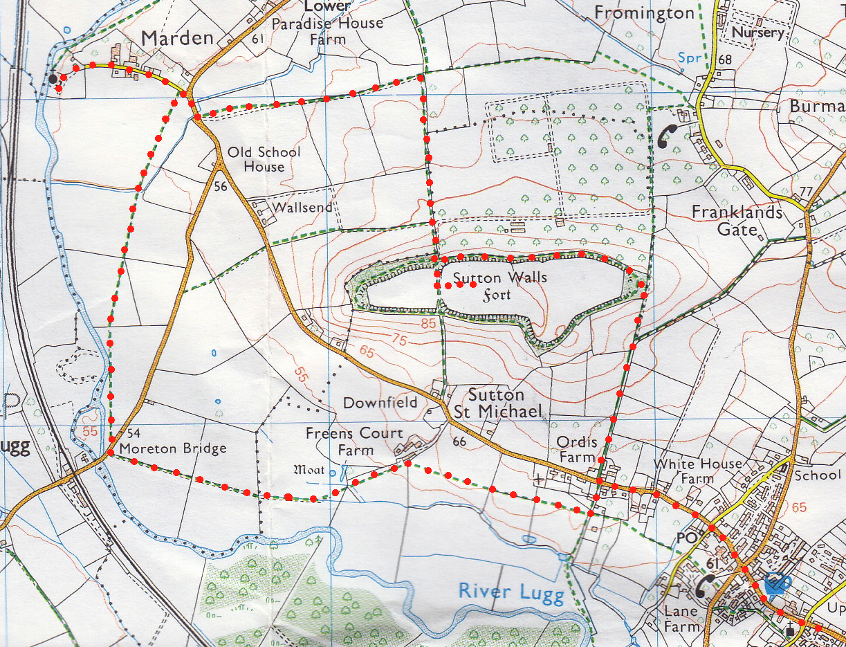
5. Moreton Bridge. Walk along the road for 20 paces and TL over a stile by a gate into F10. Continue across a large field and cross over a stile into F11. Continue in the same direction across this field, and when approaching the field end, bear L to cross a way marked wooden footbridge that’s nearest to the copse corner, into F12, (ignore the bridge on your L and the bridge that’s on your R). TR and continue up the L field edge, (the copse is on your L). Cross a stile by a gate, (the stile/gate is to the R of Freens Court Farm), into F13.
4
3

6. St Michael’s Church. This next path across a large field was poorly defined but may now be better trodden? Bear slightly R and aim for a T pole in the next field, the third T-pole from the R of a red bricked house. As you come over the brow you will see a stile in the hedge. Cross over the stile into F14 and continue in the same direction to go thru a small/large metal gate into F15 (field is adjacent to Sutton St Michael Church). The church dates back to the 12th century and has been little altered since it was first built situated above the watermeadows of the river Lugg. The Knights Hospitallers of the Order of St. John reserved the R to bury pilgrims who died in their care in the churchyard; the same churchyard is the only burial ground for the united parish today. Continue to the opposite side of this field and go thru a large/small metal gate onto a lane, TL and continue a short way to the road where you TR. Continue along this road to the start point.
6
5
2
1
1
2
3
7

